Esri Electric Utility Network Migration

Assembly Builder XML Documentation

During a migration from an Esri ArcGIS to a Utility Network asset package, conversion from ‘simple’ ArcGIS devices to UN high-fidelity devices occurs. For example, ArcGIS OH Tap Fuse:

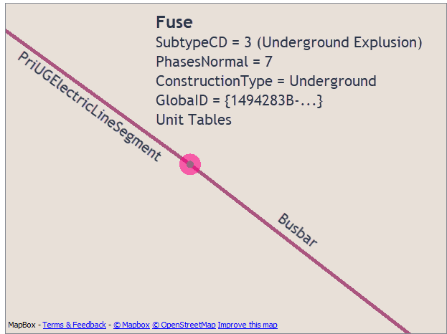

Utility Network representation:

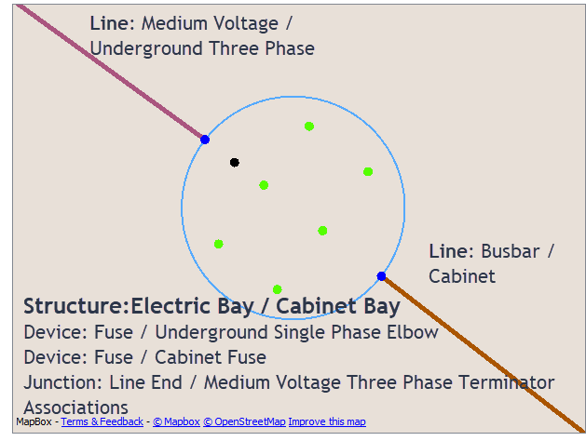

The simple point feature in ArcGIS is expanded to a highfidelity device in the Utility Network model. The composition, location and associations of the individual assets within an assembly are controlled by an XML file that is used by the ElectricDistributionAssemblyBuilder custom transformer in the electric migration workspace.

The XML defines the following:

* Assembly (i.e. Fuse Bank): asset group description, asset type description
* Devices (i.e. Arrester, Fuse): assets associated with the assembly (asset group description, asset type description) and their relative locations
* Junctions (i.e. Line End): junctions and their relative locations. For junctions the asset group description and asset type description are derived from the line connectivity.
* Terminals, if required
* Optionally, phase expansion based on the number of phases for each asset, i.e. a single assembly definition can be used for 1,2 or phase devices.
* Associations between the assembly, devices and junctions.

***Note****: all locations are a relative location to the assembly insertion point at 0,0. Column is X, Row is Y. Devices are defined horizontally.*

**Primary asset:** We refer to the ‘primary’ asset as the asset most closely aligned to the source ArcGIS device. This is set by the <keepID> tag and is generally related to a unit table record. For example if the ArcGIS device is a Fuse then the ’primary’ asset will likely be the Fuse asset. Attribution and GlobalID are inherited from the ArcGIS unit tables

**Phase Expansion**: We refer to phase expansion. This is where an asset will be cloned based on the number of phases. For example a two phase fuse will have a single Arrestor definition in the XML, but <phaseExpansion> will create two clones (one for each phase). Phase attributes are retrieved from the source ArcGIS unit table

## XML Format Definition

**Assemblies**: The main tag for the document is <assemblies>. Each individual assembly definition is contained within an <assembly> tag:

<assemblies>

<assembly>

.

.

</assembly>

<assembly>

.

.

</assembly>

</assemblies>

**Assembly**: The assembly definitions contain the assembly <assetGroupDesc> and <assetTypeDesc> tags, as well as the definitions for each asset in the assembly:

<assembly>

<assemblyCabinetKey></assemblyCabinetKey> optional: key for

assemblies where AG/AT are not unique - usually a UG device like a Fuse Electric Bay/Cabinet Bay

<assemblyGroupDesc></assemblyGroupDesc>

<assemblyTypeConfiguration>

<numberofphases>1</numberofphases> # optional: if the

# assemblyTypeDesc

# depends on phase

<assemblyTypeDesc>typeA</assemblyTypeDesc>

</assemblyTypeConfiguration>

<assemblyTypeConfiguration> # repeated for each phase

<numberofphases>2</numberofphases>

<assemblyTypeDesc>typeABC</assemblyTypeDesc>

</assemblyTypeConfiguration>

<assemblyKey2> value </assemblyKey2> # optional: secondary key

# that can be added to

# to differentiate

# assemblies also used to

# differentiate assemblies

# that have ‘optional’

# assets, i.e. arrestors

<asset>

.

.

</asset>

<asset>

.

.

</asset>

</assembly>

**XML Keys:**  The keys are used to link the FME device feature to the XML definition. There are up to four keys you can use:

**Cabinet Key:** the<assemblyCabinetKey> is optional. It can be used to clarify the feature class of the feature (usually the ArcGIS feature class) where the Asset Group/Type are ambiguous. This happens in UG devices such as Electric Bay / Cabinet Bay - which can be either a Switch or Fuse. So in the workspace you’d set the attribute assemblyCabinetKey and then have a matching tag in the XML.

**Asset group description**s: The <assemblyGroupDesc> should be the asset group description that is assigned to the Assembly point.

**Asset type description:**  <assemblyTypeConfiguration> tags contain the <assemblyTypeDesc> . If the <assemblyTypeDesc> depends on the phase then you may have multiple <assemblyTypeConfiguration> tags, and must include the <numberofphases> tag.

**Optional Key:** <assemblyKey2> is an optional key you can use to differentiate assemblies with the same Asset Group & Asset Type but with different characteristics i.e. a switch with phase expansion and one without phase expansion, or assemblies with or without arresters

***Note****: Assemblies do not require a location (row & column - see below). The assembly point is automatically located on the centerline of the highfidelity device, between the first junction and the first asset.*

**Assets**: Each asset in the assembly is defined in the asset definitions. The asset tags include the asset group description, asset type description, feature class, location, terminals and associations (links) to other assets in the assembly:

Junctions and assets have slightly different definitions:

**Junction Assets:**  simple assemblies only have two junctions per assembly. More complex assemblies (typically transformers) can have three junctions.

***Note****: The first junction (JN1) won’t have a <linkTo> tag as there is no preceding asset. (i.e. the links are from the bottom to the top of the assembly, or, the asset links to the preceding asset)*

*Asset type Description is gathered from the line connections so there is no* <assetTypeDesc> *tag.*

*In most case JN1 will have a row/column of 0,0. The location of the source ArcGIS device*

*JN1 & JN2 are referenced in the migration workspace so do not change these <id> names for junctions.*

<asset>

<id>JN2</id> # you can use any ID but we recommend

#JN1 JN2 for junctions

<linkTo> # never on JN1

<id>F1</id>

<toTerminal> Single Terminal</toTerminal>

<fromTerminal> Single Terminal</fromTerminal>

</linkTo>

<linkTo>

<id>F1</id>

<toTerminal> Single Terminal</toTerminal>

<fromTerminal> Single Terminal</fromTerminal>

<phaseOffset>-1</phaseOffset>

</linkTo>

<featureClass>Junction</featureClass>

<assetGroupDesc>Line End</assetGroup>

<row>0</row>

<column>3</column>

</asset>

For transformers JN3 may be used for the low side junction.

Temporary junctions (JN0, JN0a) can be used to help center the assembly for ‘L’ shaped assemblies.

**Device Assets**: any number of assets can be defined. You can use phase expansion to automatically place assets based on the number of phases, or explicitly define each asset in the assembly. The asset tags include the asset group description, asset type description, feature class, location, terminals and associations (links) to other assets in the assembly:

<asset>

<id>XFR1</id>

<linkTo> # link to PREVIOUS asset

<id>F1</id>

<fromTerminal> Single Terminal</fromTerminal>

</linkTo>

<linkTo>

<id>F1</id>

<fromTerminal>Single Terminal</fromTerminal>

<toTerminal>XFR:Low</toTerminal>

<phaseOffset>-1</phaseOffset>

</linkTo>

<phaseExpansion>yes</phaseExpansion> # attributes are extracted

# from the ArcGIS unit

# table

<featureClass>Device</featureClass>

<keepID>yes</keepID> # asset type desc , GlobalID

# and attributes are extracted

# from the ArcGIS unit table

<assetGroupDesc> Transformer</assetGroup>

<assetTypeConfiguration>

<numberofphases></numberofphases>

# optional: if the

# assetTypeDesc

# depends on phase

<assetTypeDesc></assetType>

# optional: if the

# assetTypeDesc

# is derived from

# unit table

</assetTypeConfiguration>

<assetTypeConfiguration> # repeats for each phase

<numberofphases></numberofphases>

<assetTypeDesc></assetType>

</assetTypeConfiguration>

<row>0</row>

<column>3</column>

</asset>

**Asset Feature class:** The asset <featureClass>, usually Device or Junction for junction assets

**Asset Group Description**: <assetGroupDesc> always required

**Asset type description:** <assetTypeConfiguration> tags contain the <assetTypeDesc> . If the <assetTypeDesc> depends on the phase then you may have multiple <assetTypeConfiguration> tags, and must include the <numberofphases> tag. <numberofphases> should be 1,2 or 3 and will match the asset type description to the number of phases on the asset.

<assetTypeDesc> will be overwritten on the primary device (<keepID>) by the source ArcGIS unit table asset type descriptions.

**Location**: The <row> (Y) and <column> (X) tags are used to locate each asset within the assembly. These are relative locations to the assembly insertion point at row 0, column 0. Devices should normally be arranged horizontally in order from left to right.

**Phase Expansion**: The <phaseExpansion> tag allows you to choose whether the asset will be cloned into a separate assets for each phase, by creating additional rows above and below the device in that column. By using phase expansion, you can create a single definition for single and multiphase devices, letting the input phasing determine the number of devices in a bank. If you use phase expansion, you must take care that there are no other devices in the rows above and below the expanded device. The allowable values are yes and no, with no being the default if the tag is not present.

Phase expansion enables the allocation of attributes (typically phasesnormal) from the source ArcGIS unit tables.

Phase expansion will create a separate association for each phase from the <linkTo> tags. When linking to another phase expanded device, the association will be created to the device with the same phase. However, if the <phaseOffset> tag is present in the link, the association will link to the offset phase. For example an offset of -1 will link phase A to C, B to A and C to B, while an offset of 1 will link A to B, B to C and C to A. <phaseOffset> = 0 (default) will link phase A to A etc.

**Associations**: The <id> and <linkTo> tags control the associations between the devices within the <assembly>. The linkage should be defined on the from device, with the <linkTo> containing the <id> of the to device. There can be multiple links on a device. The <linkTo> tag links to the previous device in the assembly definition. You can use any value for , <id> but we recommend simple abbreviations, i.e.

* JN1 JN2 for junctions
* AR1 for arrestors
* F1 for fuses
* T1 transformers
* etc.

The <id> must be unique each asset in a given assembly

**Phases Offset:** Optional tag in the <linkTo> tag. By default the associations are linear through the assembly for each phase. For cross phase associations include the <phaseOffset> tag. <phaseOffset> is used in phase expansion and is used for devices where the phases link across to another phase, such as a overhead three phase Delta transformer. Typical values will be -1, 0 , 1. (0 is the default)

**Terminals**: Optional tag in the <linkTo> tag. The link <fromTerminal> and <toTerminal> tags are used to populate attributes on the Association features that are also produced by the device (usually a transformer). If this is not set, the attribute will be set to Single Terminal. Currently used values are:

* XFR:High and XFR:Low for transformers
* Single Terminal for most other devices

**GlobalID:** GlobalID is preserved for the Assembly (from the ArcGIS source device ).

GlobalIDs for the ‘primary’ device (<keepID>) are preserved from the ArcGIS unit tables. The primary device is defined in the XML definition by the <keepID> tag. If the tag is present and set to ‘yes’ on a device, that device will be given the unit table GlobalIDs. **There should be only one device in the assembly with a <keepID> set to ‘yes’.** The Asset Type Description will also be gathered from the unit tables

**Unit Table Attributes**: Unit table attributes (usually phasesnormal) are preserved on assets with phase expansion

**Structures**: structures are not defined in the assembly builder. However, if a structure exists in the source ArcGIS data, then it will be mapped to the assembly.

## Example XML:

## <assembly>

## <!-- OH Switch Bank -->

## <assemblyDefNum>3</assemblyDefNum>

## <assemblyGroupDesc>Switch Bank</assemblyGroupDesc>

## <assemblyTypeConfiguration>

## <assemblyTypeDesc>Overhead Recloser</assemblyTypeDesc>

## </assemblyTypeConfiguration>

## <assemblyTypeConfiguration>

## <assemblyTypeDesc>Overhead Switch</assemblyTypeDesc>

## </assemblyTypeConfiguration>

## <assemblyKey2>PhaseExpansionN</assemblyKey2>

## <asset>

## <featureClass>Junction</featureClass>

## <assetGroupDesc>Line End</assetGroupDesc>

## <id>JN1</id>

## <phaseExpansion>no</phaseExpansion>

## <!-- a junction asset type desc from attached lines. -->

## <!-- we don't use the <assetTypeConfiguration> tag for Junctions -->

## <row>0</row>

## <column>0</column>

## </asset>

## <asset>

## <id>S1</id>

## <linkTo>

## <id>JN1</id>

## <fromTerminal>Single Terminal</fromTerminal>

## <phaseOffset>0</phaseOffset> <!-- default: added for clarity -->

## </linkTo>

## <!-- Phase expansion used for two things: -->

## <!-- - expand for the number of phases on the assembly -->

## <!-- - extract additional attrs from the unit table -->

## <keepID>yes</keepID>

## <phaseExpansion>no</phaseExpansion>

## <featureClass>Device</featureClass>

## <assetGroupDesc>Switch</assetGroupDesc>

## <row>0</row>

## <column>1</column>

## </asset>

## <asset>

## <id>JN2</id>

## <linkTo>

## <id>S1</id>

## <fromTerminal>Single Terminal</fromTerminal>

## <phaseOffset>0</phaseOffset> <!-- default: added for clarity -->

## </linkTo>

## <phaseExpansion>no</phaseExpansion>

## <featureClass>Junction</featureClass>

## <assetGroupDesc>Line End</assetGroupDesc>

## <!-- junction asset type desc from attached lines. -->

## <!-- we don't use the <assetTypeConfiguration> tag for Junctions -->

## <row>0</row>

## <column>2</column>

## </asset>

</assembly>